**Fiction Questions**

1. Which character do you like the most in your book? Why?
2. What do you predict will happen next in this story?
3. What is the main problem of the story? If you know, how was the problem solved?
4. Would you like to be a character in this story? Why or why not?
5. How do you feel about this story? Would you recommend it to someone else? Why or why not?
6. Summarize what you read today. What were the most important events? Did you learn anything new about the characters?
7. Is what you read believable? Why or why not?
8. Pretend you are interviewing the main character of the story. What two questions would you ask them?
9. If you could trade places with one of the characters who would it be? Why?
10. Is there anything you would change about this story? What would it be? Why would you change it?

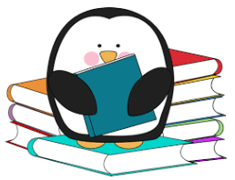

**Fiction Questions**

1. Which character do you like the most in your book? Why?
2. What do you predict will happen next in this story?
3. What is the main problem of the story? If you know, how was the problem solved?
4. Would you like to be a character in this story? Why or why not?
5. How do you feel about this story? Would you recommend it to someone else? Why or why not?
6. Summarize what you read today. What were the most important events? Did you learn anything new about the characters?
7. Is what you read believable? Why or why not?
8. Pretend you are interviewing the main character of the story. What two questions would you ask them?
9. If you could trade places with one of the characters who would it be? Why?
10. Is there anything you would change about this story? What would it be? Why would you change it?



**Nonfiction Questions**

1. What is the selection you read mainly about?
2. What did you learn while reading?
3. Why did the author probably write this selection? How do you know?
4. What was the main idea of what you read? What were the supporting details that told you more about the main idea?
5. How and where could you find out more information about the topic read about today?
6. What else would you like to know about the topic you read about?
7. Were there any text features that helped you better understand your reading? What were they and how did they help you?
8. What did you find interesting as you were reading today?
9. What do you remember most about what you read?
10. Did you find an interesting word while you were reading? What was it? Use a dictionary to find out its meaning and write a sentence of your own using the interesting word that you found.

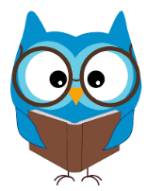

**Nonfiction Questions**

1. What is the selection you read mainly about?
2. What did you learn while reading?
3. Why did the author probably write this selection? How do you know?
4. What was the main idea of what you read? What were the supporting details that told you more about the main idea?
5. How and where could you find out more information about the topic read about today?
6. What else would you like to know about the topic you read about?
7. Were there any text features that helped you better understand your reading? What were they and how did they help you?
8. What did you find interesting as you were reading today?
9. What do you remember most about what you read?
10. Did you find an interesting word while you were reading? What was it? Use a dictionary to find out its meaning and write a sentence of your own using the interesting word that you found.

